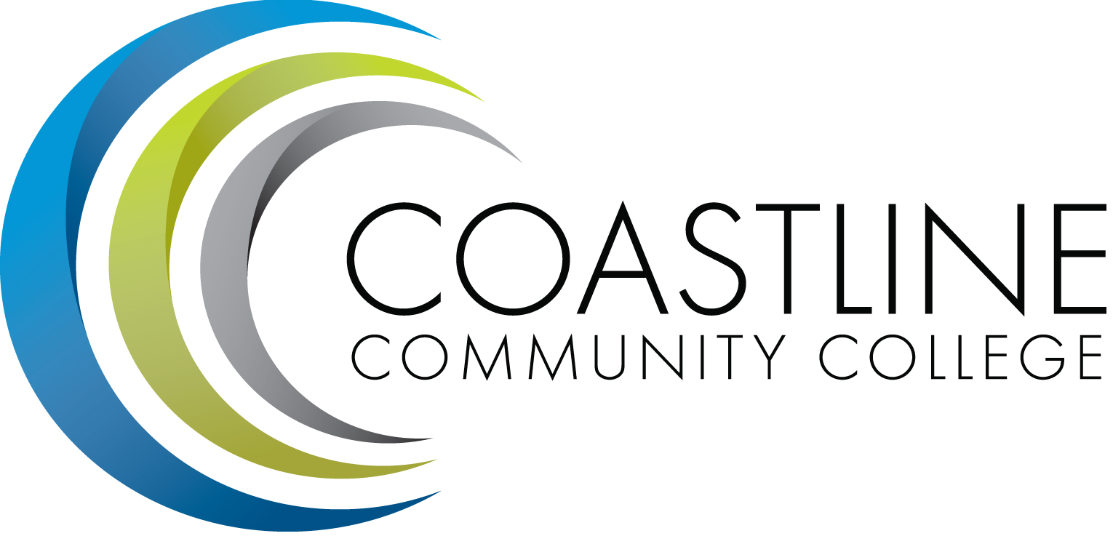
Planning, Institutional Effectiveness, and Accreditation Committee (PIEAC)
December 2, 2015
1:30 p.m. to 3:30 p.m.
Fourth Floor Conference Room

- CALL TO ORDER
  - Roll Call
  - Welcome
  - Adoption of Agenda
  - Approval of Minutes: November 18, 2015

- SPECIAL REPORTS/UPDATES
2.1 SharePoint V. Rodriguez

- DISCUSSION ITEMS
3.1 Size of Committee Survey A. Zentner

4. ACTION ITEMS
4.1 Planning Guide A. Zentner
4.2 PT Financial Aid fraud Staff Position R. Miyashiro
4.3 Mission Statement A. Holliday

5. STANDING REPORTS
5.1 Accreditation V. Rodriguez
5.2 Budget Committee R. Lockwood
5.3 Program Review A. Zentner
5.4 Grants D. Aistrich
5.5 President’s Report L. Adrian
5.6 Wing Reports V. Rodriguez, C. Nguyen, R. Miyashiro
5.7 College Council V. Rodriguez
5.8 Facilities C. Nguyen
5.9 Contract Education J. Groot
5.10 Other Committees Committee

6. ANNOUNCEMENTS (1-2 minutes per)

7. ADJOURNMENT

